Cloud Formation SNS Assignment

Problem Statement in AWS Cloud You work for XYZ Corporation. Your team is asked to deploy similar architecture multiple times for testing, development, and production purposes. Implement CloudFormation for the tasks assigned to you below. Tasks To Be Performed:

Use the template from CloudFormation task 1.

Add Notification to the CloudFormation stack using SNS so that you get a notification via mail for every step of the stack creation process.

CloudFormation Template:

Created a CloudFormation template that includes the resources required for this architecture setup. This template should define all the components needed for testing, development, and production purposes.

Ensure that the template is well-structured and includes parameters, resources, mappings, outputs, etc., as needed for your architecture.

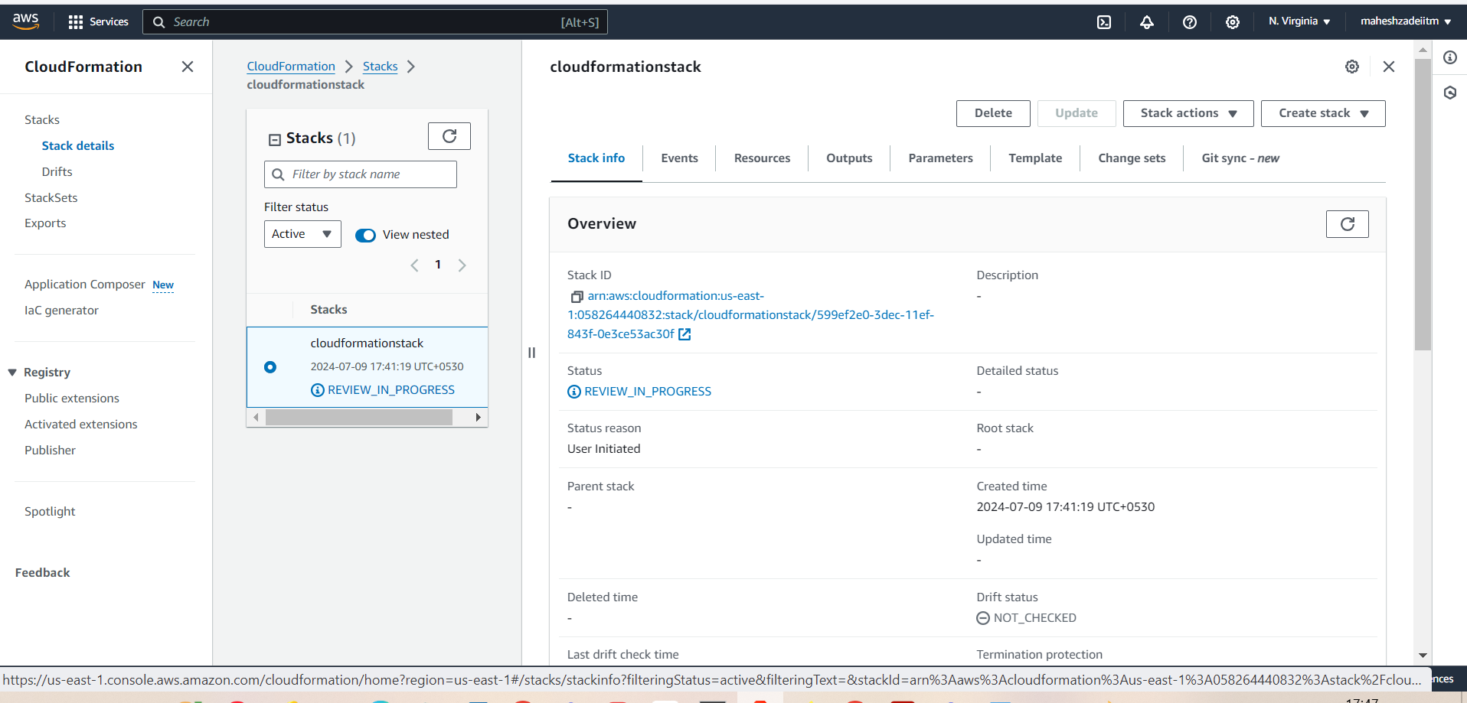

Adding Notification using SNS:

Create an SNS topic in AWS that will be used for sending notifications.

Now to create subscription

Now go to email and confirm

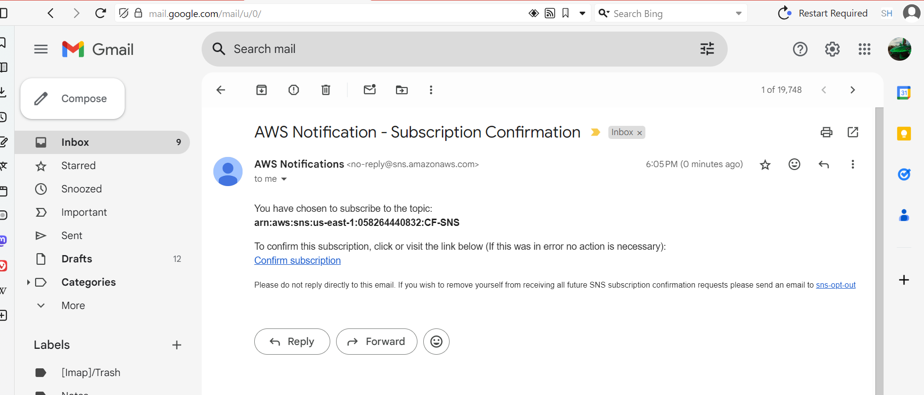

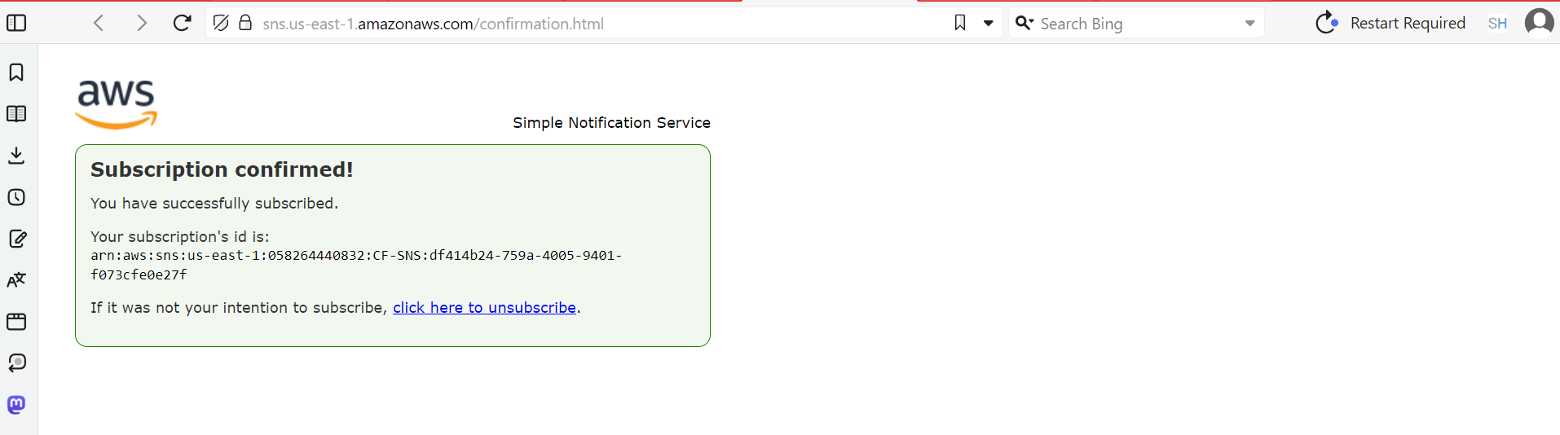

Go to SNS topic and publish the messages

Check your email

Update your CloudFormation template to include an AWS::SNS::Topic resource that creates an SNS topic.

Add the necessary permissions to allow CloudFormation to publish messages to the SNS topic.

Modified CloudFormation template to include AWS::SNS::Subscription resources to subscribe to the SNS topic. subscribe with your email address to receive notifications via email.

CloudFormation Stack Creation:

During the stack creation process, CloudFormation sending notifications to the SNS topic for each step of the stack creation process.

We are receiving email notifications for every step of the stack creation process, keeping you informed about the progress and status of the deployment.

By following these steps and incorporating notification using SNS in your CloudFormation template, we can automate the deployment process and receive notifications via email for every step of the stack creation process.

Thanks you

.